Project Design Phase-I Problem – Solution Fit Template

|  |  |
| --- | --- |
| Date | 25 October 2022 |
| Team ID | PNT2022TMID30986 |
| Project Name | Project - IoT Based Safety Gadget for Child Safety Monitoring and Notification |
| Maximum Marks | 2 Marks |

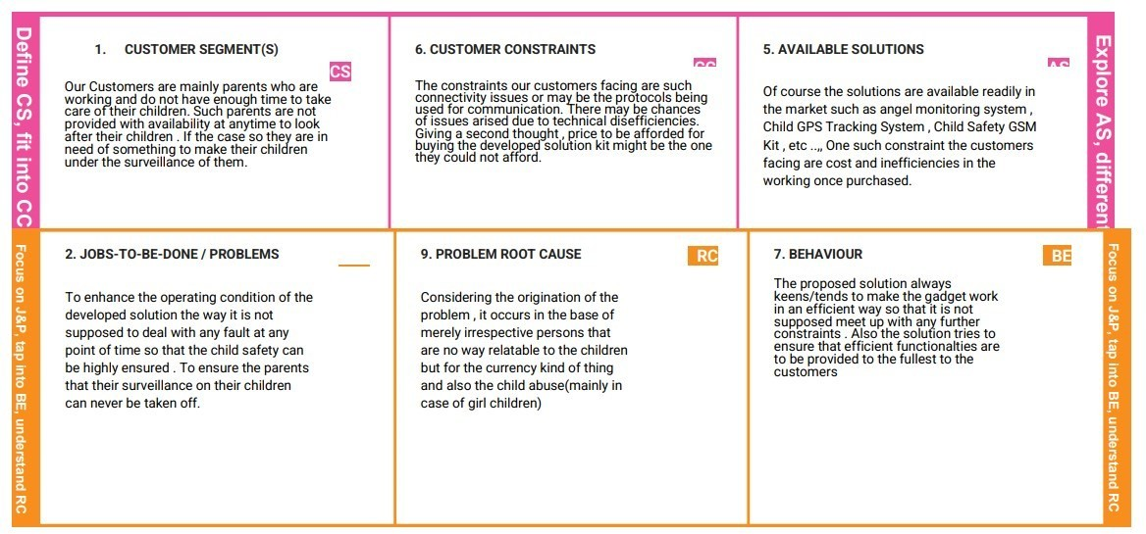

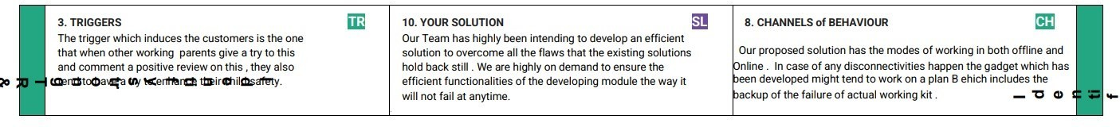

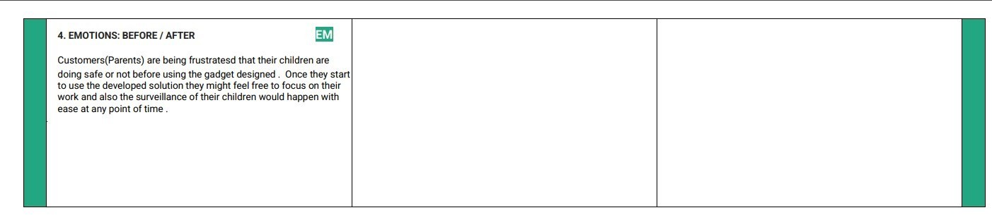

References:

1. <https://www.ideahackers.network/problem-solution-fit-canvas/>
2. [https://medium.com/@epicantus/problem-solution-fit-canvas-aa3dd59cb4fe](https://medium.com/%40epicantus/problem-solution-fit-canvas-aa3dd59cb4fe)